GTU Department of Computer Engineering

CSE 222/505 - Spring 2022

Homework #01 Report

Şiyar Tarık Özcaner

20010400421

1. System requirements

JDK, JRM and JVM are necessary to run the program.

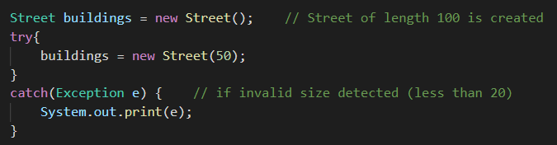

First of all a street size is needed to create the street.

The rest is left to user.

1. Class diagrams

* Is in the directory

1. Problem solutions approach

So, we are asked to create a city planning tool for designing a street which has 2 modes, edit and view and is very basic 2d-ish street which will have buildings of 4 types: houses, offices, markets & playgrounds.

Well since we are limited to work with standard arrays I found it a good practice to go with dynamic implementation because it is way more flexible to work with compared to fixed size arrays.

So, we need to have two of these (left and right) and dynamic operations (mentioned before) on these (add and remove methods). So after implementing “Building” class, it was only appropriate to create a Building[] for those operations hence “Street” class.

This really tidied up all of implementations of the view mode’s functions (list etc.) too. All you need to do is call necessary methods to get these tasks to get performed.

And finally thing is to derive building types and implement stuff like “toString” etc.

After all of these you have everything, you need to use this “city planning” tool.

1. Test cases

Test starts

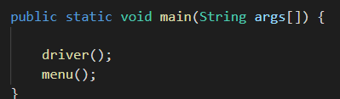

First of all the street is created.

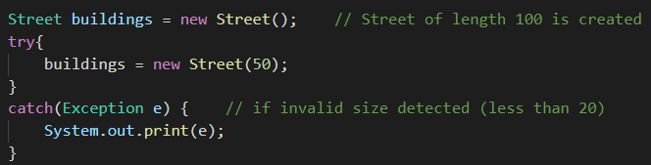

4 different building are added

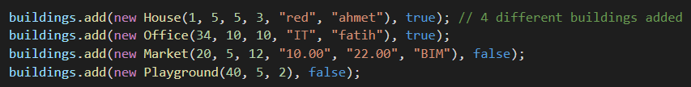

Skyline silhouette is drawn for comparison purposes,



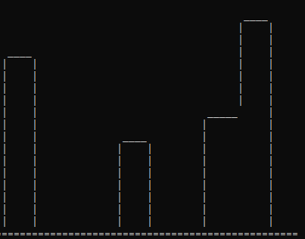

Two more building added but beware that second new one is a duplicate and causes an exception to be thrown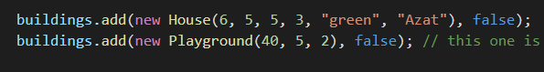



After latest additions full test is done

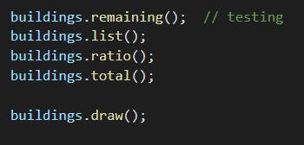



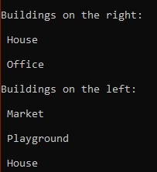





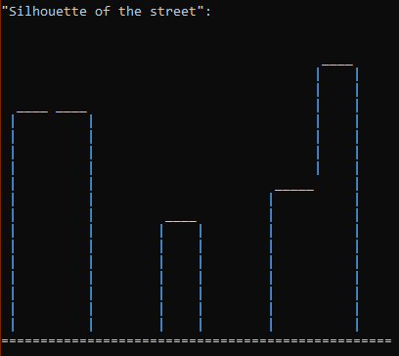

Respectively all of the view methods are tested.

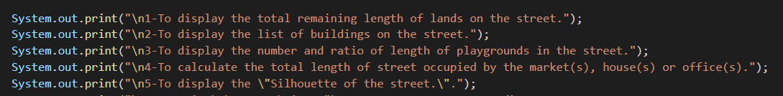

A removal is done

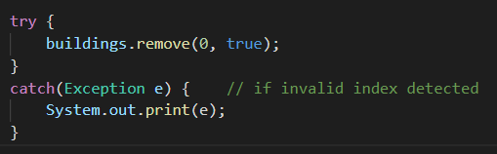

Outputs of a complete test of view

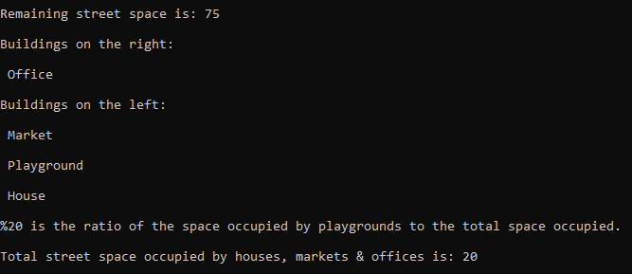

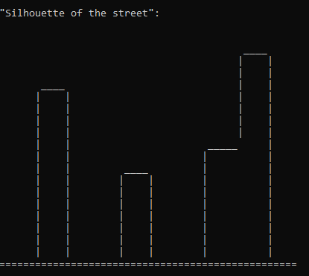

Another removal

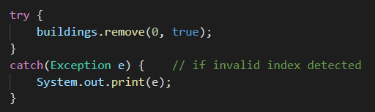

Last drawing



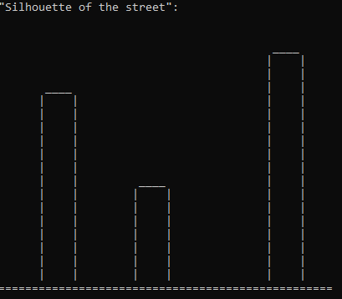

Focus is tested on a building with an index and side (“false” for left and “true” for right side)

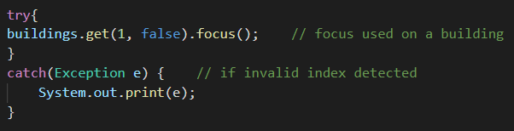

End of test now menu is called



1. Running command and results

Only “make” command is enough for all of this (test and after menu)

Contents of makefile

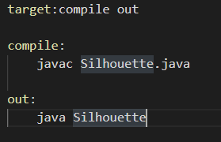

Menu asks for a valid street size

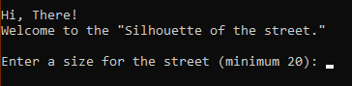

Valid vs invalid size

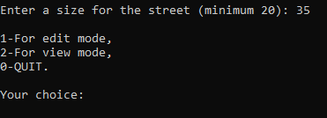

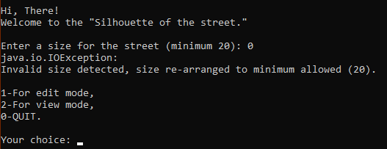

Edit mode

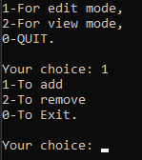

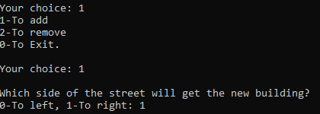

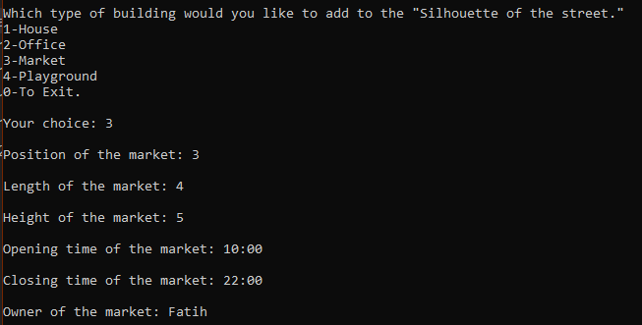

Removing

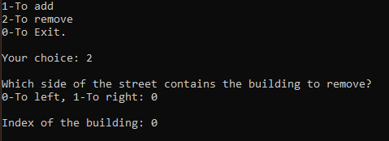

View mode

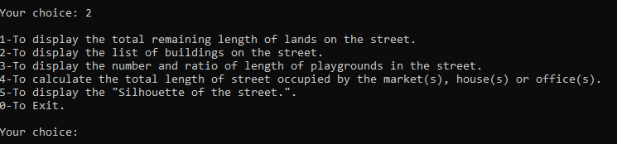

(modes are demonstrated in demo)